**Introduction to MS Excel**

**What is Excel?**

Microsoft Excel is a general-purpose electronic spreadsheet2 used to organize, calculate, and analyze data. The task you can complete with Excel ranges from preparing a simple family budget, preparing a purchase order, create an elaborate 3-D chart, or managing a complex accounting ledger for a medium size business.

Three most important components of Excel is which you need to understand first:

**1. Workbook**

A workbook is a separate file just like every other application has. Each workbook contains one or more worksheets. You can also say that a workbook is a collection of multiple worksheets or can be a single worksheet. You can add or delete worksheets, hide them within the workbook without deleting them, and change the order of your worksheets within the workbook.

### 2. Worksheet

A worksheet is made up of individual cells which can contain a value, a formula, or text. It also has an invisible draw layer, which holds charts, images, and diagrams. Each worksheet in a workbook is accessible by clicking the tab at the bottom of the workbook window. In addition, a workbook can store chart sheets; a chart sheet displays a single chart and is accessible by clicking a tab.

### 3. Cell

A cell is a smallest but most powerful part of a spreadsheet. You can enter your data into a cell either by typing or by copy-paste. Data can be a text, a number, or a date. You can also customize it by changing its size, font color, background color, borders, etc. Every cell is identified by its cell address, cell address contains its column number and row number (If a cell is on 11th row and on column AB, then its address will be AB11).

**Window Components**

Before you start using it, it’s really important to understand that what’s where in its window.

So ahead, we have all the major component which you need to know before entering the world of Microsoft Excel.

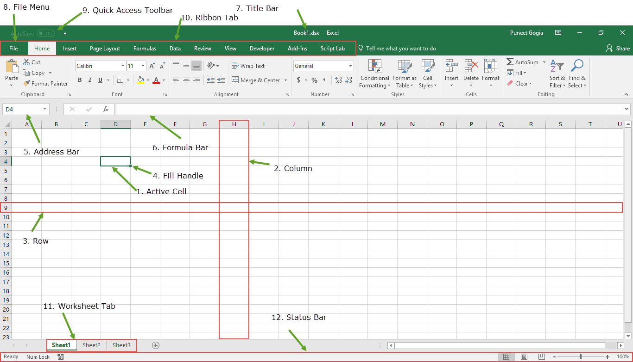

### 1. Active Cell

A cell which is currently selected. It will be highlighted by a rectangular box and its address will be shown in the address bar. You can activate a cell by clicking on it or by using your arrow buttons. To edit a cell, you double-click on it or use F2 to as well.

### 2. Column

A column is a vertical set of cells. A single worksheet contains 16384 total columns. Every column has its own alphabet for identity, from A to XFD. You can select a column clicking on its header.

### 3. Row

### A row is a horizontal set of cells. A single worksheet contains 1048576 total rows. Every row has its own number for identity, starting from 1 to 1048576. You can select a row clicking on the row number marked on the left side of the window.

### 4. Fill Handle

It’s a small dot present on the lower right corner of the active cell. It helps you to fill numeric values, text series, insert ranges, insert serial numbers, etc.

### 5. Address Bar

The address bar is the small input bar at the left side of the window.

It shows the address of the active cell. If you have selected more than one cell, then it will show the address of the first cell in the range.

### 6. Formula Bar

Formula bar is an input bar, below the ribbon. It shows the content of the active cell and you can also use it enter a formula in a cell.

### 7. Title Bar

The title bar will show the name of your workbook, followed by the application name (“Microsoft Excel”).

### 8. **​**File Menu

The file menu is a simple menu as like all other applications. It contains options like (Save, Save As, Open, New, Print, Excel Options, Share, etc).

### 9. Quick Access Toolbar

A toolbar to quickly access the options which you frequently use. You can add your favorite options by adding new options to quick access toolbar.

### 10. Ribbon Tab

Starting from the Microsoft Excel 2007, all the options menus are replaced with the ribbons. Ribbon tabs are the bunch of specific option group which further contains option.

### 11. Worksheet Tab

This tab shows the all the worksheets which are present in the workbook. By default you will see, three worksheets in your new workbook with a name of Sheet1, Sheet2, and Sheet3 respectively.

### 12. Status Bar

It is a thin bar at the bottom of the Excel window. It will give you an instant help once you start your working in Excel.

**Excel Data Input**

There are several different ways that you can input data into an Excel spreadsheet. If you spend just a few minutes learning the different methods of data input, this will help you to become much more efficient in your day-to-day work, and could save hours in the long term.

## Cell Edit Mode

The most common way to enter data into Excel is to simply select a cell and type directly into it. When you do this, the cell is automatically put into edit mode.

If you then press Enter or select a different cell in your spreadsheet, the typed content remains in the cell and the cell exits edit mode.

If you later select the same cell and begin to type, this will overwrite the existing cell contents with the new text.

Therefore, if you simply want to add to, or edit the contents of a cell, without deleting the existing cell content, you need to put the cell back into edit mode before you start to enter the new data.

You can put a spreadsheet cell into edit mode by either:

* Double clicking on the cell, or
* Selecting the cell you want to edit and then either:
  + Clicking in the formula bar, or
  + Pressing   F2

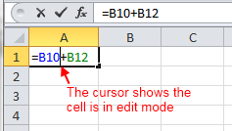

When a cell is in edit mode, a cursor appears (either in the cell or in the formula bar), and when you type or paste data into the cell, it appears alongside the existing cell contents. Also, when a cell is in edit mode, you can move your cursor through the cell contents, using either the mouse, or the left, right, up and down arrow keys on your keyboard.

## Entering a Single Value into a Range of Cells

If you want to enter the same value into several cells, you can quickly do this as follows:

* Highlight all the cells you want to populate;
* Type the value or text into the active cell;
* Press Ctrl + Enter

I.e. press the **Ctrl** key, and while holding this down, press **Enter**(or **Return**).

This copies the text you have typed into all of the cells in the selected range.

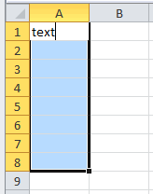 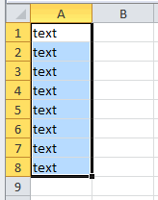

## Inputting a Series of Values

If you want to enter a series of values (e.g. 1, 2, 3, 4, ...) into a range of cells, this can be done using the Excel Auto fill.

The Excel Autofill feature can be used to populate a range of cells with either a repeat value, a series of values, or just a cell format.

To use the simple Excel Autofill:

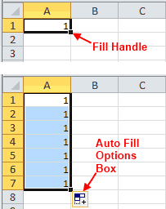

1. Enter a value into the start cell;
2. Use the mouse to drag the 'fill handle' (the small black square at the bottom right of the start cell) across the range of cells to be filled;
3. When you drag the 'fill handle' across the range of cells to be filled, Excel will fill the selected cells, by either repeating the value in the first cell or by inserting a sequence from the first cell value (e.g. 1, 2, 3, ...);
4. Click on the 'Auto Fill Options' box, which will appear at the end of your selected range of cells. This will give you the following different options:

* **Copy Cells** - copy the initial cell across the selected range;
* **Fill Series** - fill the selected range with a series of values (typically incrementing by 1), starting with the initial cell value;
* **Fill Formatting Only** - fill the selected range with the formatting, but not the values of the initial cell;
* **Fill Without Formatting** - fill the selected range with values, but do not copy the formatting from the initial cell.

Select the option that you required for the filled cells.



## Autofill Using More Than One Starting Cell Value

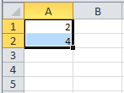

If you want Excel to recognize a series that is not a simple increment by 1, this can be done by typing the first two values of your series into the first and second cells of a range. Select both of these cells and again, drag the fill handle across the range to be filled. Excel will automatically recognize the pattern from the two initial cells and continue this across the selected range. Using this method, you can get Excel to fill cells by increments or decrements of any number (e.g. 2, 4, 6, 8, ...).

Alternatively, if you want Excel to fill cells with repeated alternating values (e.g. 1, 2, 1, 2, 1, 2, ...) you can start off the pattern in the first two (or more) cells, then, with the initial cells highlighted, drag the fill handle and then click on the 'Auto Fill Options' box. Within this box, select the option 'Copy Cells' to repeat the initial cell values across the selected range.

## Autofill Dates & Times

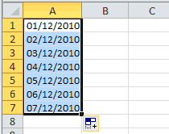

As dates and times are stored in Excel as numbers, these can also be used with the Excel Autofill.

By default, if you just type in a single date or time and drag the fill handle, dates and times will complete in a series, by adding one day (for dates), or one hour (for times). However, as with simple numbers, you have the option of clicking on the 'Auto Fill Options' box, to select a different type of Auto fill.

Times have the same four Auto fill options as are shown above, for simple numbers (i.e. Copy Cells, Fill Series,Fill Formatting Only, Fill Without Formatting). However, for dates, there are additional Auto Fill options. As well as the four options for simple numbers and times, there are also the following:

* **Fill Days** - Look for a pattern in the day when filling the selected cells;
* **Fill Weekdays** - Look for a pattern in the day when filling the selected cells, but do not include Saturdays or Sundays in the series;
* **Fill Months** - Look for a pattern in the month when filling the selected cells;
* **Fill Years** - Look for a pattern in the year when filling the selected cells.

## Autofill Text Values

The Excel Autofill will generally fill a column with text values by repeating the value(s) in the first cell(s). However, there are some text values that Excel recognizes as part of a series. These are:

|  |  |
| --- | --- |
| Weekdays (abbreviated or full names):  Excel Autofill of Weekdays |  |
| Months (abbreviated or full names):  Excel Autofill of Months |  |
| Rank:  Excel Autofill of Rank |  |
| Other text containing numbers:  Excel Autofill of Text Containing Numbers Autofill Functions and Formulas The Excel Autofill feature also works with functions and formulas in Excel. However, with this type of Autofill, there is no 'series fill' option. Instead, Excel observes the rules of [Absolute and Relative Cell References](http://www.excelfunctions.net/ExcelCellReferences.html) (i.e. if a row or column reference is preceded by a $ sign, excel will keep the reference constant as the formula is copied to other cells; Otherwise, the row or column reference will be adjusted as the formula is copied to other cells. Horizontal and Vertical Autofill As well as working down a column, the Autofill feature also works horizontally, across rows. Simply drag the fill handle across the cells that you want to populate.  Excel Autofill Across a Row Autofill Multiple Rows or Columns Simultaneously The Excel Autofill can also handle data in more than one row or column. This is shown in the example below, in which cells A1 and A2 have numeric values 1 and 2, and cells B1 and B2 both have the numeric value 3.  Highlighting cells A1 to B2, and then dragging the fill handle down columns A and B causes the Autofill to complete both columns with their own series (i.e. column A completes with 1, 2, 3, 4, ..., and column B completes with 3, 3, 3, 3, ...)  Excel Autofill More Than One Column Double Click on the Fill Handle For speed, you can Autofill a column by double-clicking on the fill handle of a highlighted cell (or range of cells). If the cells below or adjacent to the highlighted cell (or range) contain values, double clicking the fill handle causes the Autofill to fill down the current column until it reaches the end of the current data range. |  |

## Importing Data Into Excel

If you have data in a different file format, you can import this into Excel. For example, to import data from a text file:

1. Select the **From Text** option from the **Get External Data** group with the **Data** tab of the Excel ribbon.

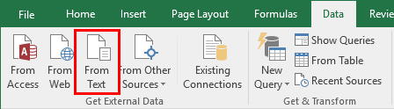

1. Use the browser to locate the text file with your data in it.

Excel then takes you through a series of steps in which you can specify how the data in the text file is to be split into separate columns, how the data is formatted in the columns, and where, in your spreadsheet, you want to paste the imported data.

## Enter a New Line

If you want to insert a new line (line break) when typing into an Excel cell, the simplest way is to:

1. Position the curser in the cell, at the point where you want the new line to be inserted.
2. Press the keyboard shortcut:

**Alt + Enter**

I.e. press the **Alt** key and while holding this down, press the **Enter** (or **Return**) key.

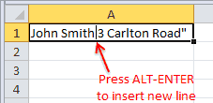

**Inputting Excel Functions**

The most obvious way of inputting an Excel Function is to simply type the function directly into an Excel cell, with its arguments enclosed in brackets.

However, if you are a beginner, or are writing a complex formula, you may find it easier to use the Function Arguments dialog box, which helps you to input functions and formulas more easily.

## Using the Function Arguments Dialog Box

The 'Function Arguments' dialog box automatically pops up when you select an Excel function using one of the following methods:

* **Method 1:**Select the Insert Function button (denoted by the **ƒ*χ***symbol) from the left side of the formula bar (see right), and then select a function name from the 'Insert Function' dialog box.

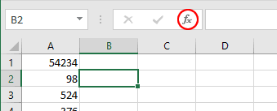

or

* **Method 2:** Select a function from one of the lists in the 'Function Library' group, on the **Formulas** tab of the Excel ribbon (see below).

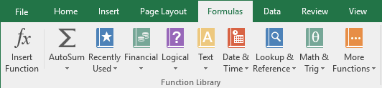

When you select a function using one of the methods above, Excel automatically displays the 'Function Arguments' dialog box to assist you in inputting your selected function.

## Typing Functions Directly Into a Cell

As you become more used to inputting Excel functions and formulas, you might find it quicker to insert functions by typing them directly into a cell or into the formula bar.

In this case, Excel still provides you with useful prompts, as shown in the example below. In this example, the user has started to type the Excel [If function](http://www.excelfunctions.net/ExcelIf.html) directly into the formula bar. It can be seen that, once the user has typed in the function name and the opening bracket, Excel displays a mini prompt, which shows the syntax of the function, and indicates the arguments that should be inserted.

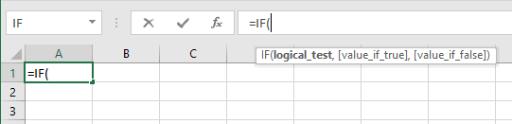

You can also use the mouse to select ranges that you want to form a part of any Excel function or formula. To do this, ensure your cursor is in the position (within the formula) where a cell reference or range of cells is required and then simply use the mouse to select the required range. Excel will then automatically insert a reference to the selected range into your function, as shown in the image below.

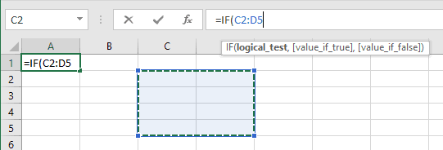

The above range selection method can be used to select cells in any Worksheet of any Workbook that is currently open. This is particularly useful if you are selecting a range in a separate workbook, as the reference needs to include the workbook name, the worksheet name, and the cell range, which can be cumbersome to type, and prone to typing errors.

**Excel Sum Function**

## Function Description

The Excel SUM function adds together a supplied set of numbers and returns the sum of these values.

The syntax of the function is:

**SUM( number1, [number2], ... )**

Where the number arguments are a set of numbers (or arrays of numbers) that you want to find the sum of.

## Excel Sum Function Examples

The following spreadsheet shows three simple examples of the Excel Sum function:

|  |  |  |  |  |  |  |  |  |  |  |  |  |  |  |  |  |  |  |  |  |  |  |  |  |  |
| --- | --- | --- | --- | --- | --- | --- | --- | --- | --- | --- | --- | --- | --- | --- | --- | --- | --- | --- | --- | --- | --- | --- | --- | --- | --- |
| Formulas:   |  |  |  | | --- | --- | --- | |  | **A** | **B** | | **1** | 5 | =SUM( 15, 29 ) | | **2** | 7 | =SUM( A1, A2 ) | | **3** | 9 | =SUM( A1:A3 ) | | Results:   |  |  |  | | --- | --- | --- | |  | **A** | **B** | | **1** | 5 | 44 | | **2** | 7 | 12 | | **3** | 9 | 21 | |

The above examples show that each argument to the Sum function can be supplied as a single value or cell reference, or as an array of values or cells.

## Function Description

The Excel PRODUCT function returns the product (multiplication) of a supplied set of numerical values.

The syntax of the function is:

**PRODUCT( number1, [number2], ... )**

Where the number arguments are a set of numbers (or arrays of numbers) that you want to calculate the product of.

**Excel Product Function**

## Excel Product Function Examples

The following spreadsheet shows three simple examples of the Excel Product function:

|  |  |  |  |  |  |  |  |  |  |  |  |  |  |  |  |  |  |  |  |  |  |  |  |  |  |
| --- | --- | --- | --- | --- | --- | --- | --- | --- | --- | --- | --- | --- | --- | --- | --- | --- | --- | --- | --- | --- | --- | --- | --- | --- | --- |
| Formulas:   |  |  |  | | --- | --- | --- | |  | **A** | **B** | | **1** | 3 | =PRODUCT( 3, 6 ) | | **2** | 2 | =PRODUCT( A1, A2 ) | | **3** | 5 | =PRODUCT( A1:A3 ) | | Results:   |  |  |  | | --- | --- | --- | |  | **A** | **B** | | **1** | 3 | 18 | | **2** | 2 | 6 | | **3** | 5 | 30 | |

The above example spreadsheet shows that each argument to the Product function can be supplied as a single value or cell reference, or as an array of values or cells.

**Excel Quotient Function**

## Function Description

The Excel QUOTIENT function returns the integer portion of a division between two supplied numbers.

The syntax of the function is:

**QUOTIENT( numerator, denominator )**

Where the arguments are as follows:

|  |  |  |
| --- | --- | --- |
| numerator | - | The number to be divided. |
| denominator | - | The value that divides the numerator. |

## Quotient Function Examples

The following spreadsheet shows four examples of the Excel Quotient function.

|  |  |  |  |  |  |  |  |  |  |  |  |  |  |  |  |  |  |  |  |  |  |  |  |  |  |  |  |  |  |  |  |
| --- | --- | --- | --- | --- | --- | --- | --- | --- | --- | --- | --- | --- | --- | --- | --- | --- | --- | --- | --- | --- | --- | --- | --- | --- | --- | --- | --- | --- | --- | --- | --- |
| Formulas:   |  |  |  | | --- | --- | --- | |  | **A** | **B** | | **1** |  | =QUOTIENT( 5, 2 ) | | **2** |  | =QUOTIENT( 10, 2.2 ) | | **3** | 5.5 | =QUOTIENT( A3, 2.667 ) | | **4** | -7 | =QUOTIENT( A4, 2 ) | | Results:   |  |  |  | | --- | --- | --- | |  | **A** | **B** | | **1** |  | 2 | | **2** |  | 4 | | **3** | 5.5 | 2 | | **4** | -7 | -4 | |

**Excel Subtraction Function**

**The Excel – Operator**

|  |  |  |
| --- | --- | --- |
|  | **A** | **B** |
| **1** | = 11 - 2 - 5 |  |
| **2** |  |  |
| **3** |  |  |

The simplest type of Excel subtraction formula consists of the = sign, followed by two or more numbers, with the - operator in between them.

For example, to subtract the numbers 2 and 5 from 11, type the following into any Excel cell:

**= 11 - 2 – 5** which returns the value **4**.

As with all Excel formulas, instead of typing the numbers directly into your subtraction formula, you can use references to cells containing numbers.

The Excel subtraction formula in cell A1 of the spreadsheet on the right subtracts the values in cells B2 and B3 (i.e. the values 2 and 5) from the value in cell B1 (i.e. the value 11).

Again, the formula returns the value **4**.

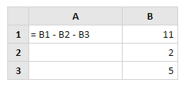

**Excel Copy and Paste**

**Simple Excel Copy and Paste**

The most simple Excel copy and paste uses the following steps:

1. Select an Excel cell, or range of cells.
2. Copy the cell(s) by either:
   * Right clicking with the mouse and selecting 'Copy' from this menu;
   * Selecting the **Copy** option from the home tab of the Excel ribbon;
   * Using the keyboard shortcut, Ctrl + C   (i.e. select the **Ctrl** key and while holding this down, press **C**).
3. Click on the location where you want to paste the copied cell(s).
4. Paste the copied cell(s) by either:
   * Right clicking with the mouse and selecting 'Paste' from this menu;
   * Selecting the **Paste** from the home tab of the Excel ribbon;
   * Using the keyboard shortcut, Ctrl + V   (i.e. select the **Ctrl** key and while holding this down, press **V**).

## Paste Special

Normally when you perform an Excel copy and paste, all information from the copied cell(s) is pasted into the new cell(s). This includes any formulas or other cell contents, *and* the cell formatting.

However, sometimes you might want to only paste one part of the original copied cells, (e.g. just the cell values or just the cell formatting) into the new range. You can do this using the Excel 'Paste Special' command, which is found in the menu that appears when you right click the mouse.

The 'Paste Special' command can also be accessed from the 'Clipboard' group on the home tab of the Excel ribbon.

In recent versions of Excel (Excel 2010 or later), the right click menu and the 'Paste' menu contain 'Paste Special' shortcuts. Examples of these are shown below:

Examples of Paste Special Shortcuts:

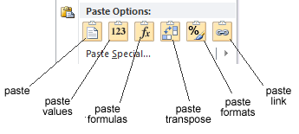

### Paste Special Values Example

A simple paste special example is shown in the two images below.

The first image shows the set of cells A1-A15, which have coloured formatting and also contain data values. If you want to copy the values, but not the formatting of cells A1-A15, into cells B1-B15, you could do this as follows:

1. Select and copy cells A1-A15;
2. Select cell B1 (or cells B1-B15) and then select **Paste Special** (from the Excel ribbon or the mouse right-click menu);
3. You will be presented with the 'Paste Special' dialog box (also shown in the left image below). Select the option **Values** from this dialog box and click **OK**.

The image on the right below shows the result of the Paste Special. Note that the values from cells A1-A15 have been copied into cells B1-B15, but the formatting has not been copied across.

|  |  |
| --- | --- |
| Excel Paste Special Values Original Example Spreadsheet With Dialog Box  *Original Spreadsheet with Paste Special Dialog Box* | Excel Paste Special Values Results Spreadsheet  *Paste Special Values Result* |

Of course, if you have one of the more recent version of Excel (Excel 2010 or later), you wouldn't need to open up the 'Paste Special' dialog box, as you can paste values only by using the Paste Special Values shortcut, Paste Special Values Shortcut.

## Paste Special Transpose

You can see, from the above example, that the Values option is just one of several options linked to the Excel Paste Special feature.

As well as pasting selected attributes of the copied cells, the Paste Special command can be used to perform simple transformations. One example is the Transpose option which, in the example below, has been used to copy cells A1-A6, and paste these into the cell range C1-H1.

|  |  |  |  |  |  |  |  |  |  |  |  |  |  |  |  |  |  |  |  |  |  |  |  |  |  |  |  |  |  |  |  |  |  |  |  |  |  |  |  |  |  |  |  |  |  |  |  |  |  |  |  |  |  |  |  |  |  |  |  |  |  |  |  |  |  |  |  |  |  |  |  |  |  |  |  |  |  |  |  |  |  |  |  |  |  |  |  |  |  |  |  |  |
| --- | --- | --- | --- | --- | --- | --- | --- | --- | --- | --- | --- | --- | --- | --- | --- | --- | --- | --- | --- | --- | --- | --- | --- | --- | --- | --- | --- | --- | --- | --- | --- | --- | --- | --- | --- | --- | --- | --- | --- | --- | --- | --- | --- | --- | --- | --- | --- | --- | --- | --- | --- | --- | --- | --- | --- | --- | --- | --- | --- | --- | --- | --- | --- | --- | --- | --- | --- | --- | --- | --- | --- | --- | --- | --- | --- | --- | --- | --- | --- | --- | --- | --- | --- | --- | --- | --- | --- | --- | --- | --- | --- | --- |
| |  |  |  |  | | --- | --- | --- | --- | |  | **A** | **B** | **C** | | **1** | andy |  |  | | **2** | dave |  |  | | **3** | carl |  |  | | **4** | beth |  |  | | **5** | ian |  |  | | **6** | pete |  |  |   *Before Paste Special Transpose* | |  |  |  |  |  |  |  |  |  | | --- | --- | --- | --- | --- | --- | --- | --- | --- | |  | **A** | **B** | **C** | **D** | **E** | **F** | **G** | **H** | | **1** | andy |  | andy | dave | carl | beth | ian | pete | | **2** | dave |  |  |  |  |  |  |  | | **3** | carl |  |  |  |  |  |  |  | | **4** | beth |  |  |  |  |  |  |  | | **5** | ian |  |  |  |  |  |  |  | | **6** | pete |  |  |  |  |  |  |  |   *Paste Special Transpose Result* |

## Use Paste Special to Perform Arithmetic Operations

The Paste Special command can also be used to perform a simple arithmetic operation on the contents of the target cells. The values in the copied cells are added to, subtracted from, multiplied by or used to divide the target cells.

An example of this is shown below. Columns A and B of the example spreadsheet both contain numeric values and the Paste Special command is used to subtract the values in column A from the values in column B. This is done by copying column A, selecting column B, and then selecting 'Paste Special', with the **Subtract** option.

|  |  |  |  |  |  |  |  |  |  |  |  |  |  |  |  |  |  |  |  |  |  |  |  |  |  |  |  |  |  |  |  |  |  |  |  |  |  |  |  |  |  |  |  |  |  |  |  |  |  |  |  |  |  |  |  |  |  |
| --- | --- | --- | --- | --- | --- | --- | --- | --- | --- | --- | --- | --- | --- | --- | --- | --- | --- | --- | --- | --- | --- | --- | --- | --- | --- | --- | --- | --- | --- | --- | --- | --- | --- | --- | --- | --- | --- | --- | --- | --- | --- | --- | --- | --- | --- | --- | --- | --- | --- | --- | --- | --- | --- | --- | --- | --- | --- |
| |  |  |  |  | | --- | --- | --- | --- | |  | **A** | **B** | **C** | | **1** | 54 | 66 |  | | **2** | 58 | 86 |  | | **3** | 95 | 100 |  | | **4** | 34 | 56 |  | | **5** | 23 | 32 |  | | **6** | 87 | 101 |  |   *Before Paste Special Subtract* | |  |  |  |  | | --- | --- | --- | --- | |  | **A** | **B** | **C** | | **1** | 54 | 12 |  | | **2** | 58 | 28 |  | | **3** | 95 | 5 |  | | **4** | 34 | 22 |  | | **5** | 23 | 9 |  | | **6** | 87 | 14 |  |   *Paste Special Subtract Result* |

Note that, in the above example, instead of subtracting every cell of column A from column B, we could have subtracted a single cell of column A from every cell of column B. To do this, simply copy a single cell to start with, instead of a range of cells. Then, as in the example above, select column B and then select the **Paste Special→Subtract** option.

**Excel Find and Replace**

## Basic Excel Find

In order to find an occurrence of a specific value in an Excel spreadsheet:

1. 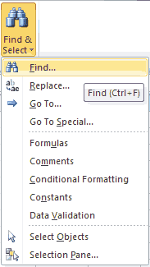

Click on the **Find & Select** icon (which is located within the 'Editing' group on the **Home** tab of the Excel ribbon), then select the option **Find...** (see right).

Note that the keyboard shortcut for this is Ctrl + F.

1. You will be presented with the Excel Find and Replace dialog box, with the Find tab selected, as shown below:

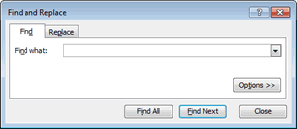

1. Within the dialog box:
   * Type the text or numeric value that you want to find into the **Find what:** field;
   * Click on the **Find Next** button.

This will take you to the next occurrence of the required value within the current worksheet.

### Excel Find All

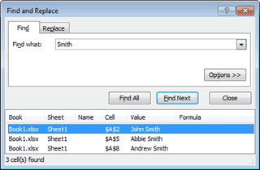

If you want to find all occurrences of a specific value, you can click on the **Find All** button within the Find and Replace dialog box. This brings up a list of all occurrences of your search value, as shown on the right.

Clicking on each of the values in the list will take you to the corresponding cell in your spreadsheet.

## Basic Excel Find and Replace

In order to replace one or more occurrences of a specific value in an Excel spreadsheet:

1. 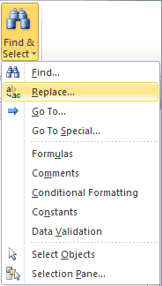

Click on the **Find & Select** button (which is located within the **Editing** group of the **Home**tab), then select the option **Replace...** (see right).

Note that the keyboard shortcut for this is Ctrl + H.

1. You will be presented with the Excel Find and Replace dialog box, with the Replace tab selected, as shown below:

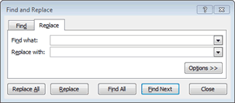

1. Within the dialog box:
   * Type the text that you want to find into the **Find what:** field;
   * Type the text that you want to replace with into the **Replace with:** field;

Note that you can leave this field blank if you simply wish to remove all instances of the 'find text', (i.e. replace with nothing).

* + Click on the **Find Next** button. This will take you to the first occurrence of the 'find text'.
  + In order to replace the current instance of the 'find text' with the specified 'replace' text, click on the **Replace** button. The text will be replaced and you will be taken to the next occurrence of the 'find text'.

### Excel Replace All

If you are confident that you want to replace all occurrences of the 'find text' with the 'replace text' (without checking each instance individually), simply click on the **Replace All** button within the dialog box.